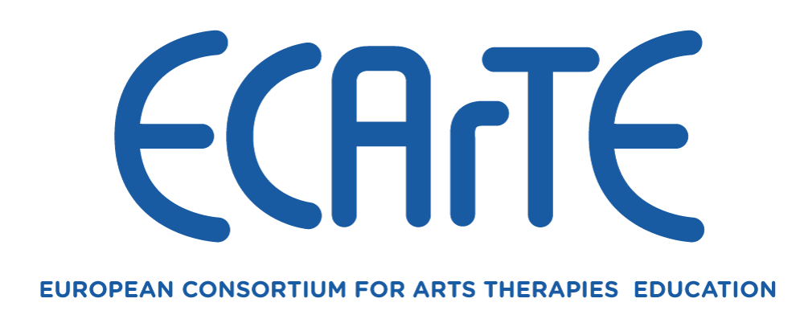

Membership
The Consortium was established in 1991 with assistance from ERASMUS. Accordingly, membership is linked to recognition by the European Union of Institutions of Higher Education. Currently the Consortium has three categories of membership.

Categories of Membership
- Full Member
Full Membership is offered to Institutions of Higher Education / Universities that offer courses in accordance with the criteria below. Such Institutions must be formally recognised as such by appropriate European Union (EU) authorities, such as ERASMUS. Only Full Members have voting rights and the right to hold office on the Executive. Each Full Member Institution has one vote only.
- Associate Member
Institutions of Higher Education / Universities in the process of developing courses in the Arts Therapies as described above may join the Consortium as Associate Members and thereby benefit from the experience and expertise offered by the Consortium. Normally, an Associate Membership will be reviewed after a maximum of four years. Each course will be reviewed on an individual basis, following which: a fixed-term renewal of Associate Membership may be recommended, the cessation of Membership proposed, or an invitation to apply for Full Membership offered. It is expected that applications for Full Membership would follow normal procedures.
- Partner Member
Partner Membership may be given to Institutions of Higher Education / Universities that do not qualify for either full or Associate Membership but that hold a legitimate partnership involving the Arts Therapies with a full member/s of the Consortium. By 'Legitimate Partnership' we mean a formally agreed contractual arrangement - e.g. a franchise arrangement, within the area of Arts Therapies education / training.

Associate and Partner Members will be invited to attend all General Assembly meetings of the Consortium including all activities that take place during the General Assembly. They do not, however, have the right of representation on the General Assembly (i.e., they do not have voting rights) and cannot hold office on the Executive.

ECArTE MEMBERSHIP CRITERIA

Introduction
It is ECArTE’s mission to seek compatibility across university qualification systems in Europe, mutual recognition of degree qualifications and increased staff and student mobility. The Consortium’s Membership Criteria have been updated to exploit our commonalities and to make room for diversity. The Consortium encourages the use of the European Community Course Credit Transfer System (ECTS) as a vehicle for developing and maintaining shared standards for arts therapists within the European Community. All ECArTE Member States have undertaken to work towards attaining the Bologna Declaration’s objectives (1999).
The criteria for membership to ECArTE is subject to a fast-changing educational and social landscape. There are complex articulations of qualifications in different European Countries and ECArTE is keen to remain observant of these differences and inclusive in its practice. To this end, where an application is unsuccessful, feedback will be offered to the institution and where possible, support and guidance offered.

Criteria for university education as an Arts Therapist for Full Membership of ECArTE:
Education programmes should be:
- public sector university-validated
- Government/State recognised.
- and should follow the ‘BAMA’ System.
- The recommended structure is based on two cycles –
- basic and advanced / Bachelor and Masters:
i.e. 3-5 year model for BA/MA (i.e. 3 or 4 years for the BA, 1 or 2 for the MA):
3 + 2 years (i.e. 180 ECTS + 120 ECTS). - In following this cycle, it is expected that entry onto a Masters programme would be via a Bachelor degree in the arts therapies or a related discipline.
or
4 + 1 years of study (i.e. 240 ECTS + 60 ECTS). – In following this cycle, it is expected that entry onto a postgraduate programme would be via a degree in the arts therapies.

Training should be provided through specialised arts therapy courses and lead to a specific award in Arts Therapy (i.e., in Art Therapy, Dance-Movement Therapy, Dramatherapy or Music Therapy). Increasingly, ECArTE university programmes are offered at Masters level.
At least, 60 ECTS, or the equivalent, should focus exclusively on a single modality specialisation in the Arts Therapies (as listed above).

Curriculum must include:
• the development of artistic and experiential practice
• a critical engagement with the basic principles, theories and practice of arts therapies
- the study of related psychological and psychotherapeutic approaches
- methods and approaches for research and clinical enquiry
• supervised clinical practice

It is recommended that students be in personal therapy, throughout their training.
Membership Fees
The Annual Membership Fee will be reviewed each year at the General Assembly Meeting and will be determined by the Executive. The same membership fee will be applicable to all three categories of membership. The Annual Membership Fee covers a full calendar year (January to December) and must be paid by 1st June of any one year. The Membership Fee for the current year (2025) is €800.
Once an institution’s membership has been ratified by the Consortium, the costs of one member representative’s attendance at the General Assembly (including travel, hotel accommodation and meals) will be included in the Annual Membership Fee.

Notes regarding application
All applications should be made on an ECArTE Application Form for Membership and emailed to the ECArTE Executive Co-ordinator, whose contact details are given below.
All applicants are asked to submit with their application documentation which verifies:
- university validation of each course
- professional recognition of the awards
All applicants are asked to seek and include, wherever possible, endorsement of their application from an existing ECArTE Member Institution.
Partner Membership are asked to attach copies of documents that establish a `Legitimate Partnership' with an existing Full member of the Consortium. Applicants for Partner Membership must be endorsed by a partner, which is an existing Full Member of the Consortium.
Ratification of a new membership will normally be taken during an annual General Assembly of the Consortium. The applicant is required to send a representative to the meeting to give a brief presentation about their university and their arts therapy programme/s.
Applicants are asked to email a scanned copy of their application, along with relevant supporting documents:

Application forms and all enquiries should be emailed to:
Richard Hougham, Chair ECArTE,
email: richard.hougham@cssd.ac.uk
Applicants are requested to submit papers to us by 31st December, if they wish their application to be considered for acceptance at the next ECArTE General Assembly.

MEMBERS OF THE EXECUTIVE BOARD 2025

Chair: Richard Hougham
Royal Central School of Speech and Drama
University of London
UK

Vice-Chair: Marián López Fernández Cao
Faculty of Education
University Complutense of Madrid
Spain
Coordinator: Juan L. Köstner
Faculty of Psychology
Universidad de Barcelona
Spain

Treasurer: Ofira Honig
Faculty of Arts
Beit Berl Academic College

MEMBERSHIP APPLICATION FORM

1 Category of membership required
(please indicate whether you are applying for Full, Associate or Partner membership).

2 Title of Institution of University

3 Full postal address
(including title of department, telephone number, email and web address)

4 Name of Principal / President/ Vice Chancellor / Rector of University

5 Name of contact person (with details of their post / position)

6 Title of Course/s in the Arts Therapies given by the above (please give details of all courses, or in the case of applications for Associate Membership, planned courses, together with the length of the course in years, the title of the award and the level of the award, module titles and credit weighting. Associate Member applicants should also indicate the anticipated start date of the new course/s)

Please also attach a summary of the philosophy and structure of your programme/s, the module titles and credit weighting and any special features of the programme to which you wish to draw our attention.

7 Validation arrangements (if the courses given above are validated or joint validated by institutions other that the institution named in this application please give full details)

8 Student Details (please give details of student numbers and whether the courses are offered or will be offered as full or part-time, or both.

9 Name/s of person/s who will represent you if membership is granted (up to two
individuals from any one member institution may attend meetings of the Consortium):

10 Is the Institution named in this application formally recognised by ERASMUS or other European Union Higher Education Department? (Please provide full details and, if possible, copies of correspondence regarding this).

11 Is there an ECArTE Member Institution, which you can name that will endorse your application? We recommend that all applicants provide at least one contact.

12 Validation and Approval: Is your course nationally validated and approved?
YES / NO.
Please name, below, the organisation/s which validate and approve your course/s.

I have read the membership regulations of ECArTE and testify that to my knowledge the details given in this application are correct.

Signed Date

(Principal / President/ Vice Chancellor/ Official Stamp of your University Rector of University)

Please PRINT name of Principal/Rector

…………………………………………………

Please note that you application form must include your university’s official stamp. Thank you.

